BEHÇET’S PATIENTS SUPPORT
Supporting those with a rare, complex and lifelong disease.

To access these services, patients must be registered at one of the three Behçet’s Syndrome Centres of Excellence.
Details of how to be referred to and registered at a Behçet’s Syndrome Centres of Excellence, are available via the Behçet’s Syndrome Society; http://www.behcets.org.uk/wp-content/uploads/2017/08/BPC-Referral-information-August-2017.pdf
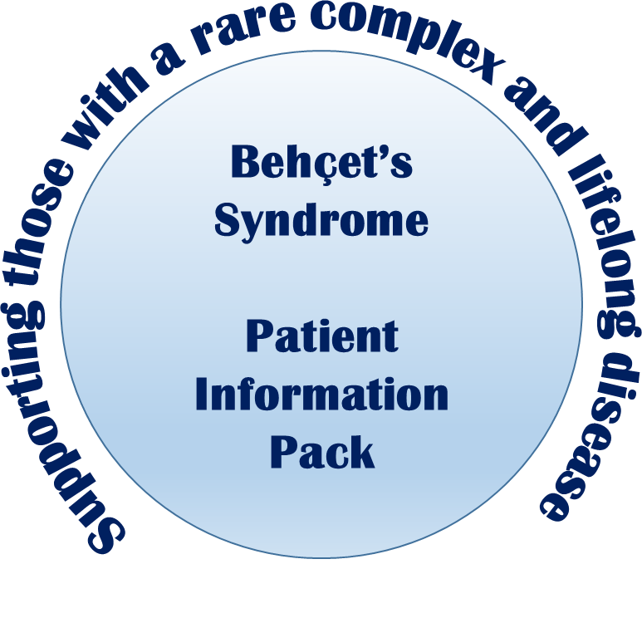
WORKING IN PARTNERSHIP WITH THE
BEHÇET’S SYNDROME SOCIETY AND THE NHS
BEHÇET’S PATIENTS SUPPORT
Supporting those with a rare, complex and lifelong disease.

Behçet’s Centre of Excellence (London)
Behçet’s Support Coordinator: Jean Christians
Email: jean@behcetsdisease.org.uk
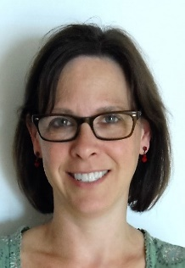
Jean has worked as London Support Co-ordinator since 2013. Prior to working with the Behçet’s Team she has worked in various hospitals and day centres here in the UK and, back “home” in America, setting up therapeutic activities and groups for both the patients and families she has worked with. She has a Master’s Degree from New York University in Therapeutic Recreation and Leisure studies, and has a keen interest in empowering the lives of our patients, through social, recreational and leisure pursuits. Jean enjoys a bit of running, yoga and cycling.
Behçet’s Centre of Excellence (Birmingham)
Behçet’s Support Coordinator: Rebecca Hyder

Email: rebecca@behcetsdisease.org.uk
Rebecca has worked as Birmingham Support Co-ordinator since March 2016. Before joining the Behçet’s team, Rebecca worked for Onside Independent Advocacy in mentoring and employment support for adults with mental ill-health and ran a range of CBT based MoodMaster wellbeing groups. Prior to that, Rebecca qualified as a Person-Centred Counsellor and Psychotherapist working predominantly with young people. Rebecca’s special interests include Autism, food and wellbeing.

Behçet’s Centre of Excellence (Liverpool)
Behçet’s Support Coordinator: Jacqueline Pooler

Email: jacqueline@behcetsdisease.org.uk
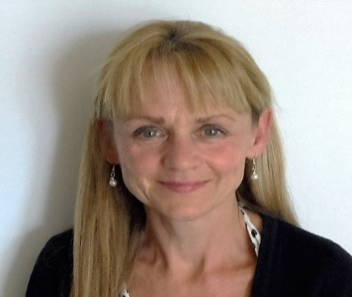
Jacqueline has worked as the Liverpool Support Co-ordinator since August 2014. Prior to joining the Behçet’s team, she worked in various nursing roles including midwife, district nurse and Macmillan Clinical Nurse Specialist. This is her first non-nursing role but one that uses many of her skills acquired over the last 4 decades to support patients who attend the Liverpool Centre. Jacqueline is specifically interested in working with patients to self -manage the non-medical aspects of their condition and helping them identify and maximise their life opportunities.
BEHÇET’S PATIENTS SUPPORT
Supporting those with a rare, complex and lifelong disease.

About Behçet’s Patients Support:

The Behçet’s Syndrome Centres of Excellence, funded by NHS England, were set up in three NHS Trusts in Birmingham, Liverpool and London to provide care for patients with Behçet’s syndrome.

The Behçet’s Centres of Excellence offer care in the form of multi-disciplinary clinics and help patients to access high cost drugs.

The aim of the Centres of Excellence is to ensure that patients with Behçet’s syndrome can access timely diagnosis and receive optimal treatment across England. They provide a “one stop” service, aiming to provide the best care from diagnosis for this rare, chronic disease.

Each hospital has specialists with relevant expertise and provides multidisciplinary teams that work together within each hospital and with the other Centres to further improve the care of Behçet’s syndrome patients.

Behçet’s Support Coordinators help with non-medical areas of patient care:

- Attend weekly NHS Behçet’s clinics.

- Provide practical and emotional support.

- Liaise with employers, educational establishments and organisations such as Department of Work and Pensions (Benefits) to ensure a better understanding of Behçet’s Syndrome.

- Signpost to specialist agencies including money and benefits advice services, occupational therapy, physiotherapy, housing, social services and advocacy services.

- Link Behçet’s syndrome patients with other patients and Behçet’s Syndrome Society support groups.

- Support patients in maintaining employment, leisure activities or volunteering opportunities.

- Conduct home visits where appropriate.

- Provide information packs containing the latest accurate and relevant information Behçet’s Syndrome. (www.behcets.org.uk/information-for-patients/bss-factsheets/).

BEHÇET’S PATIENTS SUPPORT
Supporting those with a rare, complex and lifelong disease.

How the Centres of Excellence work:

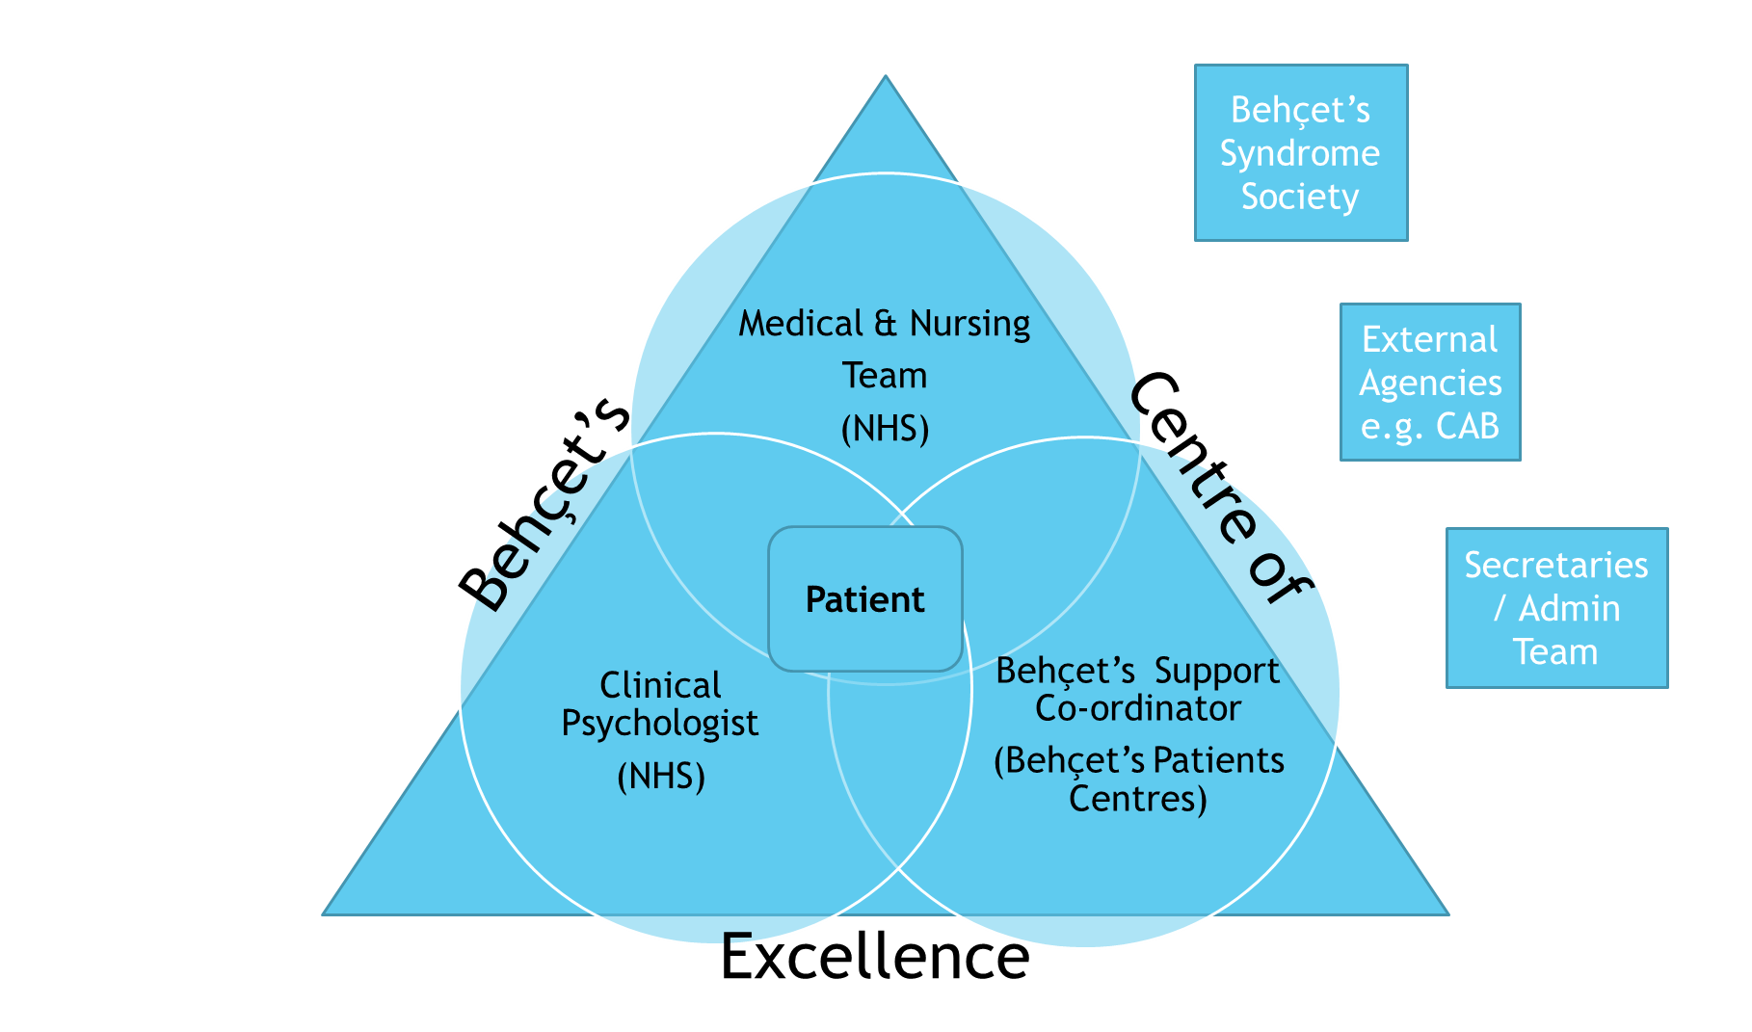

BEHÇET’S PATIENTS SUPPORT
Supporting those with a rare, complex and lifelong disease.

HINTS & TIPS:

- It is more important than ever that patients collect evidence to support PIP applications, recent consultant letters are the most accurate record of current state of health.

- Patients should consider joining websites such as http://www.benefitsandwork.co.uk/ to receive the latest updates and advice on benefits; http://www.disabilityrightsuk.org/ also provides advice and information for adult benefits and http://www.cafamily.org.uk/ for children.

- Support Co-ordinators can signpost patients to agencies for more detailed benefits or money advice.

- Support Co-ordinators write general support letters to go with benefits application and explain how Behcet’s impacts on daily life.

- Patients are made aware that they are not necessarily entitled to PIP and other benefits and that an award is not guaranteed.

- Support Co-ordinators can support patients to stay in work and education by liaising with employers, schools, colleges and Universities for example in discussing reasonable adjustments.

BEHÇET’S PATIENTS SUPPORT
Supporting those with a rare, complex and lifelong disease.

PATIENT FEEDBACK:

- Help with university information and my understanding of the illness.

- I feel that I have someone to discuss any issues I have with and don't feel alone in my illness.

- Have PIP now and blue badge.

- I feel happy in the knowledge that should I need advice in the near future I can contact the Support Coordinator.

- Massive difference and always prepared to go the extra mile.

- Offered support, friendly would seek assistance if needed.

- Is always welcoming and professional.

- Is very caring and good at her job.

- Useful to know they are there.

- She came to visit a Support Group of Behcets patients, that was very helpful.

- Helped me to get my ESA benefit.

- Very friendly and helpful.

- Nothing too much trouble always willing to help.

- She is doing a very nice job.

- I was showed all the support that was on offer, to which I had no idea existed.

The most recent Quality of Life Survey completed in late 2014 showed that of the 116 respondents 80% were either “somewhat satisfied or very satisfied” with the Centres

